**„LEARNING HOW TO SOLVE PROBLEMS” – TRAINING MATERIALS**

Subjectivity is a concept from which the idea of ​​a student wishing to take responsibility for an individual learning process, is derived. Subjectivity is *"the causative power or potential human capacity for self*-transformation*"*( Hejnicka-Bezwińska, 2008, p. 497).

It assumes that the child is perceived as an individual who has the right to their own independence and self-development of their self, has a specific identity that allows them to distinguish themselves from other individuals, and their deeds and actions largely depend on them

**PROBLEM**

……………………………………………………………………………………………………………………………………………………………………………………………………………………

Stages of solving problem:

1. ……………………………………………………………………………………………………..

2. ……………………………………………………………………………………………………..

3. ……………………………………………………………………………………………………..

4. ……………………………………………………………………………………………………..

5. ……………………………………………………………………………………………………..

**Exercise 1)**

- Which system for solving the problems they chose on the beginning?

…………………………………………………………………………………………………………

- How did they change it to work out a solution in the group?

…………………………………………………………………………………………………………

- What should the teacher pay attention to?

…………………………………………………………………………………………………………

- What should a student do to better acquire knowledge ? …………………………………………………………………………………………………………

**CONCLUSIONS**:

…………………………………………………………………………………………………………

…………………………………………………………………………………………………………

…………………………………………………………………………………………………………

…………………………………………………………………………………………………………

…………………………………………………………………………………………………………

…………………………………………………………………………………………………………

…………………………………………………………………………………………………………

…………………………………………………………………………………………………………

**INTERESTING FACT**

Researches show that thinking is the essence of problem solving.

This interaction often leaves uncertainty and some unsolved problems that need to be rethought and reordered.

# **SOLVING PROBLEMS**

## Each student group is a collection of different personalities, skills and talents, and as a teacher you have to take into account that they will look at each problem differently. But what can you do to turn these differences into something constructive?

## **Problem solving requires clear communication in which all concerns and perspectives are taken into account**.

* Make sure that each instruction to complete the task is understandable to the group!
* Remember that although each problem is different and requires individual analysis, you will avoid a continuous crisis and hasty decisions.
* Guide students through the problem-solving process - with a well-defined plan and goals.

**6 STEPS FOR SOLVING PROBLEMS:**

1. **Defining the problem**
2. **Problem description**
3. **Break the problem into prime factors**
4. **Generating ideas, to collect available options for solving the problem**
5. **Choosing the solution**
6. **Results control**
7. **Defining the problem**

**Questions worth to ask:**

* What's happening?
* What are the symptoms?
* Where's the source?
* What is the problem?
* What will the effects be if we don't solve the problem?
* Why did the problem appear?

1. **Problem description**

**Questions worth to ask at this stage of the proces:**

* How do people affected by the problem see it?
* How can we describe this problem to someone from outside?

1. **Breaking the problem into prime factors**

**Questions worth to ask at this stage of the proces:**

* How does it affect the people involved (directly and indirectly)?
* What are the most harmful aspects?
* What are the least harmful aspects?
* How will the situation develop over the next hours, days, months?

1. **Generating ideas, to collect available options for solving the problem**

## **During brainstorming, there are 2 important rules to remember:**

* let ideas flow
* in this phase all ideas are accepted

1. **Choosing the solution**

Choose one solution - one that everyone agrees to. When you make this decision, everyone should respect it and be consistent about it..

1. **Results control**

In the last step, you and the team must control the results of your solution. Determine if it has successfully eliminated the problem - if not, start the process again and find a more effective solution.

**The use of „6 steps for solving problems” model in my work:**

* A
* K
* K
* A
* K
* A
* K

…………………………………………………………………………………………………………

…………………………………………………………………………………………………………

…………………………………………………………………………………………………………

…………………………………………………………………………………………………………

…………………………………………………………………………………………………………

#### …………………………………………………………………………………………………………**EMOTIONS IN THE LEARNING PROCESS**

Educational processes contain a very strong emotional component. The value of emotions for the effectiveness of the process is priceless. It is worth paying attention to the course of emotional phenomena in academic education.

Cognitive processes are particularly determined by emotions. Student : constructs in his mind:

* constructs his own image of the virtual reality in which he moves,
* constructs own image of people participating in it,
* constructs his own image of the tool he uses,
* constructs knowledge structures.

There is a strong relationship between the process of knowledge acquisition and emotion. Information processing depends on the appearance of emotions, which on the one hand strengthen the process of coding information in memory, and on the other decide to recall memory deposits. The participation of emotions is very important in the learning processes.

Communication, closely linked with the emotional aspect of knowledge, enables the use of coupling between emotions , and perception, selection and coding of information acquired and processed them into usable structures and skills.

Emotions generally defined as joy that comes from achieving intermediate goals and commitment to what you do are of key importance for the learning process.

Emotions affect cognitive processes, and are sometimes even are a condition to start them up.

#### **Functions of emotions in the learning process:**

* orientation function - emotions provide information about objects,
* activation function - emotions provide the energy necessary to start and conduct various cognitive operations,
* "modulation" function - emotions provide the amount of energy that ensures optimal functioning of cognitive processes,
* metacognitive function - which is related to orientation in one's own cognitive processes and the choice of such procedures that may be most effective in a given situation.

It is also worth paying attention to the fact that moods and emotions modify not only behavior but also thinking.

Emotions can be a feature of the remembered material or a feature of the mental state of the subject. They can also provide a favorable context for remembering and retrieving information. Emotionally marked stimuli are better remembered than stimuli that are not marked in this way. Intense emotions improve the remembering of major details and worsen the remembering of background details. The learning process itself is also an important stimulus to emotions.

~prof. M. Chmielecki

**Using the theory „Emotions in learning process” in my work:**

* A
* K
* K
* A
* K
* A
* K

…………………………………………………………………………………………………………

…………………………………………………………………………………………………………

…………………………………………………………………………………………………………

…………………………………………………………………………………………………………

…………………………………………………………………………………………………………

…………………………………………………………………………………………………………**EXERCISE 2)**

**TEACHER**

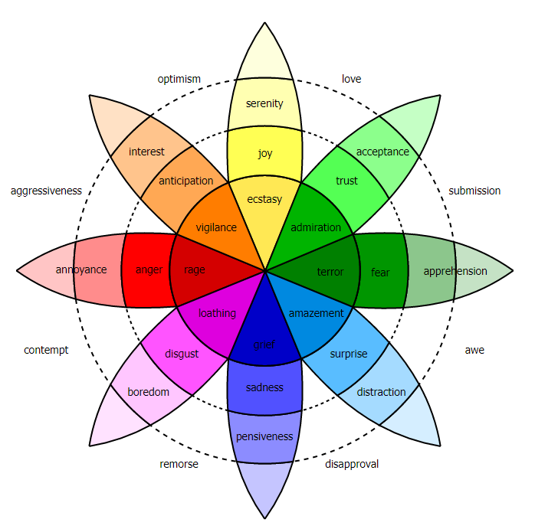

**………………………………………………………………………………………………………………………………………………………………………………………………………………………………………………………………………………………………………………………………………………………………………………………………………………………………………………………………………………………………………………………………………………………………………………………………………………………………**

**STUDENT**



**………………………………………………………………………………………………………………………………………………………………………………………………………………………………………………………………………………………………………………………………………………………………………………………………………………………………………………………………………………………………………………………………………………………………………………………………………………………………**

**CONCLUSIONS**:

…………………………………………………………………………………………………………

…………………………………………………………………………………………………………

…………………………………………………………………………………………………………

…………………………………………………………………………………………………………

…………………………………………………………………………………………………………

…………………………………………………………………………………………………………

…………………………………………………………………………………………………………

…………………………………………………………………………………………………………

…………………………………………………………………………………………………………

…………………………………………………………………………………………………………

…………………………………………………………………………………………………………

…………………………………………………………………………………………………………

**EXERCISE 2)**

- How was the work of both group STUDENTS AND TEACHERS?

…………………………………………………………………………………………………………

- What was the most difficult?

…………………………………………………………………………………………………………

- What did you manage to work out?

…………………………………………………………………………………………………………

- What anticipation of emotions in both groups overlapped?

…………………………………………………………………………………………………………

- What are the differences?

…………………………………………………………………………………………………………

**NOTES**:

…………………………………………………………………………………………………………

…………………………………………………………………………………………………………

…………………………………………………………………………………………………………

…………………………………………………………………………………………………………

…………………………………………………………………………………………………………

…………………………………………………………………………………………………………

…………………………………………………………………………………………………………

…………………………………………………………………………………………………………

…………………………………………………………………………………………………………

…………………………………………………………………………………………………………

…………………………………………………………………………………………………………

…………………………………………………………………………………………………………

…………………………………………………………………………………………………………

…………………………………………………………………………………………………………

…………………………………………………………………………………………………………

…………………………………………………………………………………………………………

…………………………………………………………………………………………………………

**Bibliography**

Adamowski, T., Frydecka, D., Kiejna, A. (2007). Nauczanie oparte na rozwiązywaniu problemów (PBL) – możliwości zastosowania w psychiatrii. Psychiatria Polska, XLI, 2. Pobrano z lokalizacji: http://www.psychiatriapolska.pl/uploads/images/ PP_2_2007/Adamowski%20s163_Psychiatria%20Polska%202_2007.pdf.

Anderson John R. (1998), Uczenie się i pamięć. Integracja zagadnień, WSiP  
Wieczorek D.,

Apple (2011). Challenge Based Learning. A Classroom Guide. Pobrano z lokalizacji: <https://images.apple.com/education/docs/CBL_Classroom_Guide_Jan_2011.pdf>.

Bellanca, J.A. (red.) (2015). Deeper learning. Beyond 21st Century Skills. Bloomington.

Downloaded from: http://www.nelson.com/pl4u/wp-content/uploads/2014/11/ DeeperLearning_LookInside.pdf?e1d0f5.

Bloom, B., Mesia, B., Krathwohl, D. (1964). Taxonomy of Educational Objectives (Two vols: The Affective Domain & The Cognitive Domain). New York.

Demont, H., Istance, D., Benavides, F. (red.) (2013). Istota uczenia się. Wykorzystanie wyników badań w praktyce. Warszawa.

Ekman P., Davidson R (red.) (2002) Natura emocji. Podstawowe zagadnienia., Gdańsk GWP

<http://www.e-mentor.edu.pl/artykul/index/numer/10/id/161>